1) UI Color Mismatch
Parakh UI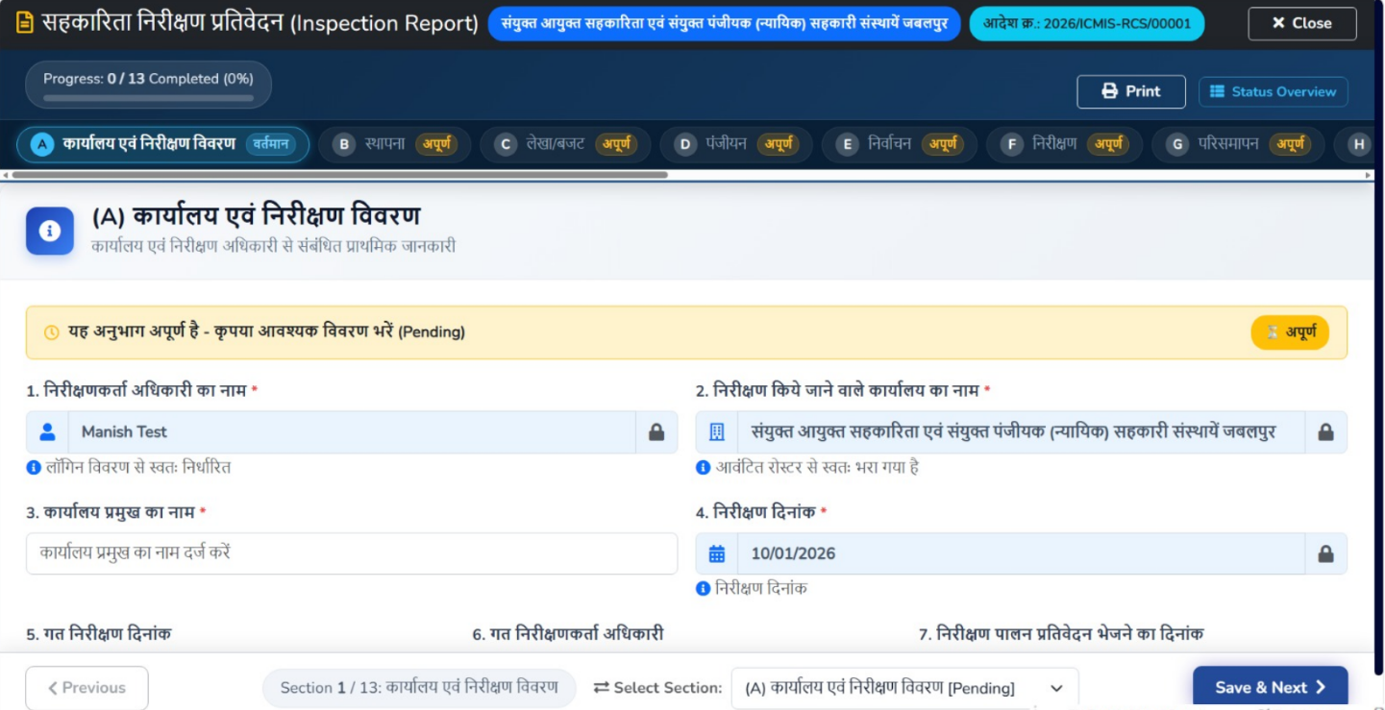
ICMIS UI
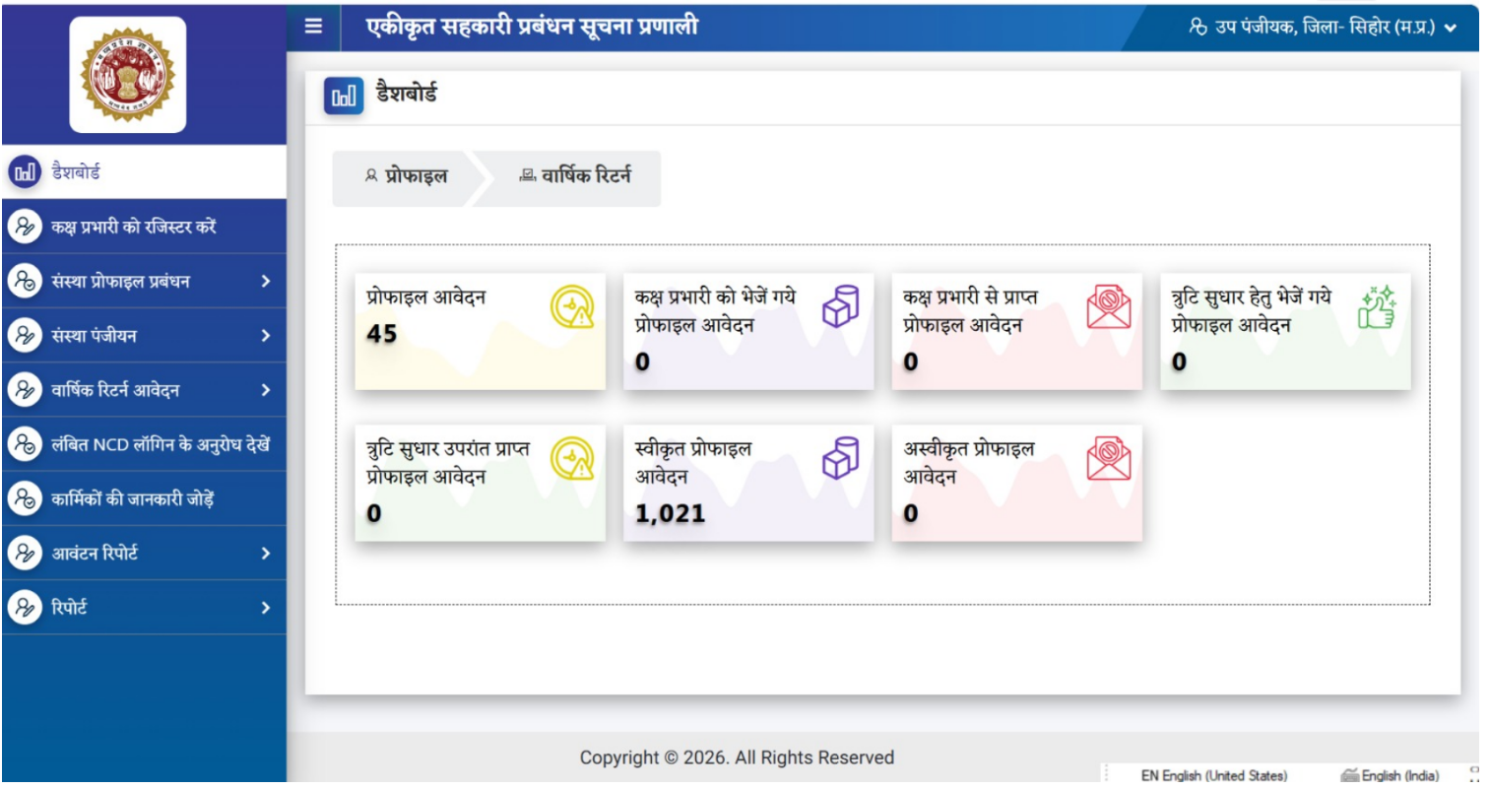

2) कार्यालय प्रमुख का नाम - Auto (presently enterable)
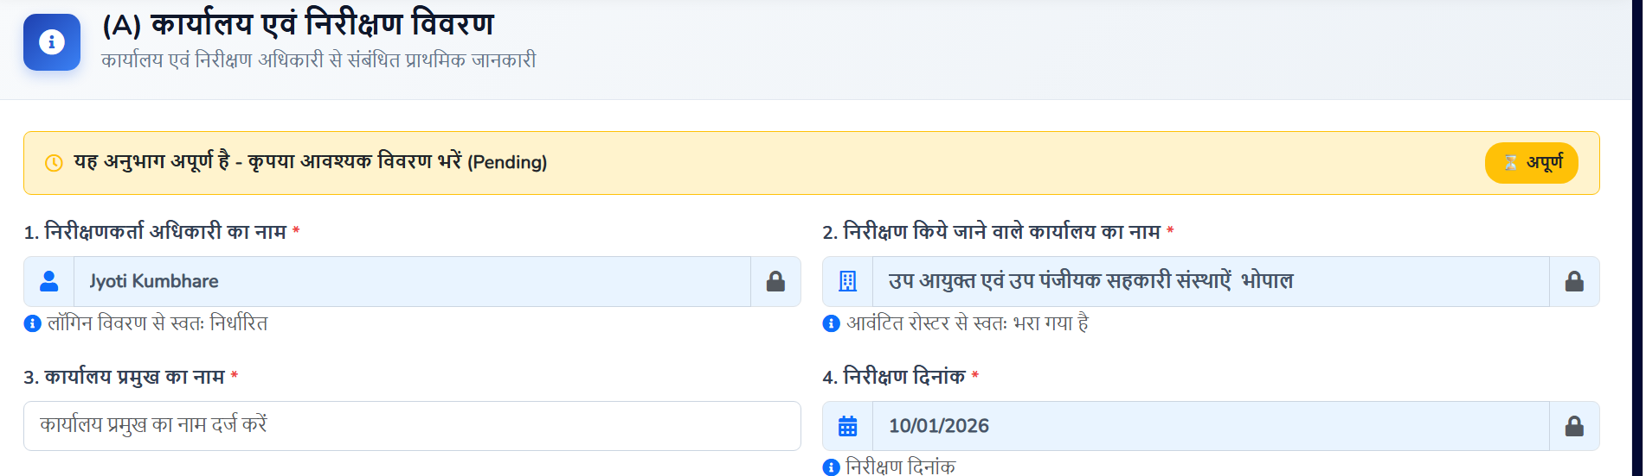

3) निर्वाचन
Change word अधिक्रमण to अतिष्‍ठान
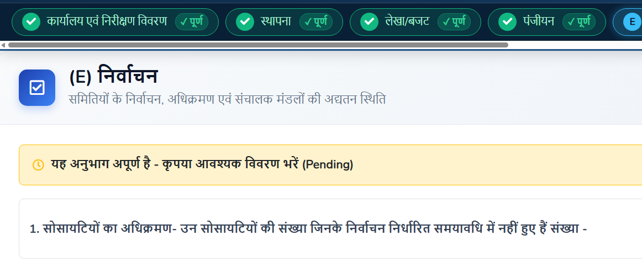
4) 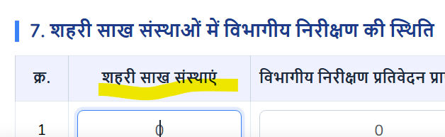
Highlighted field is auto

5) अंकेक्षण tab
वसूली के प्रकरण : निष्पादन -> धारा
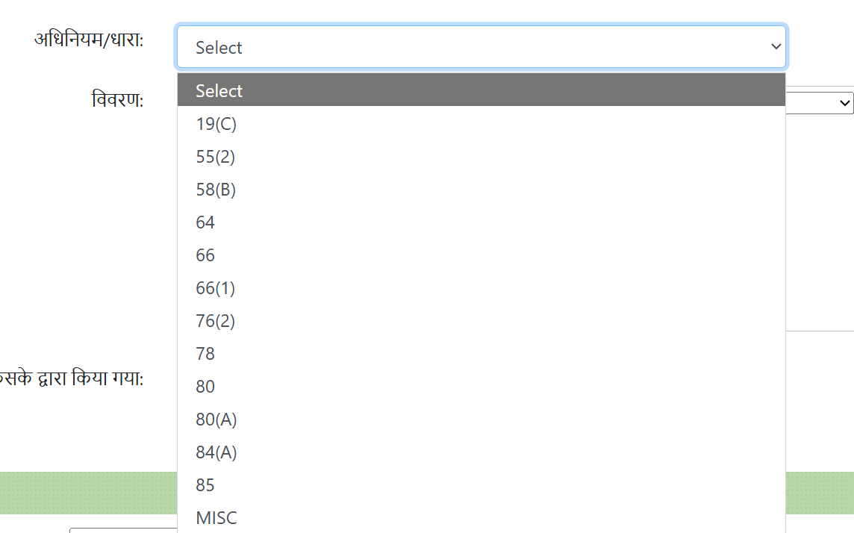
Add all these sections .
Presently few are being showed.
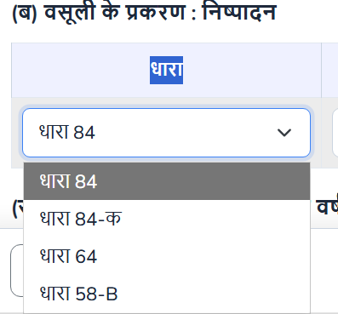

Same for below न्यायालयीन प्रकरणों की जानकारी :-
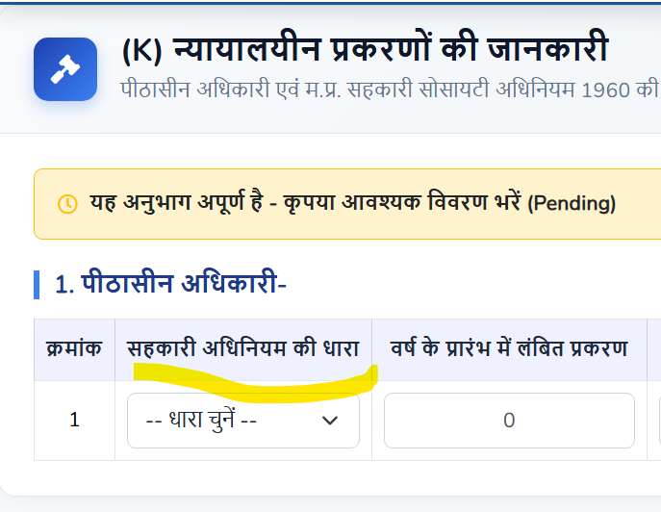

6) Some checks
AR – Only AR Offices inspection
DR- AR , DR Offices inspection
JR- JR,DR,AR Inspection

7) User Master should have कार्यालय का नाम field.
8) Any officer should not get inspection for his / her own office (कार्यालय)
9) This inspection will be issued to officers only one time yearly . Orders to multiple officers will be given. So if Say Divison – Morena is given for inspection to an officer ,then Morena should not be visible to be assigned to any other in the list of values.
10) A Message should go to users with order number and roaster list.

